DAILY ONLINE ACTIVITIES SUMMARY

|  |  |  |  |  |  |  |  |
| --- | --- | --- | --- | --- | --- | --- | --- |
| **Date:** | **19-06-2020** | | | | **Name:** | **Kavya.R.Shetty** | |
| **Sem & Sec** | **6th sem, ‘A’ sec** | | | | **USN:** | **4AL17CS042** | |
| Online Test Summary | | | | | | | |
| **Subject** | | **Programming in C** | | | | | |
| **Max. Marks** | |  | | **Score** | |  | |
| Certification Course Summary | | | | | | | |
| **Course** | Workshop on “**Applications of Python Programming in DA and ML”** | | | | | | |
| **Certificate Provider** | | | **-** | **Duration** | | | **-** |
| Coding Challenges | | | | | | | |
| **Problem Statement: 1 Java and 2 C program and 1 python program** | | | | | | | |
| **Status: executed** | | | | | | | |
| **Uploaded the report in GitHub** | | | | **Yes** | | | |
| **If yes Repository name** | | | | <https://github.com/kavya-shetty765/DAILY-STATUS> | | | |
| **Uploaded the report in slack** | | | | **Yes** | | | |

# Programming in C

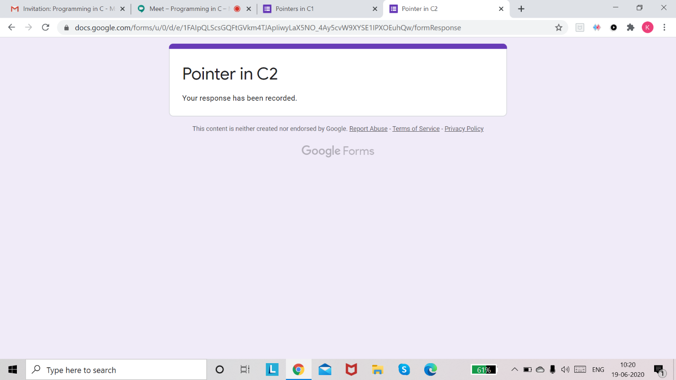

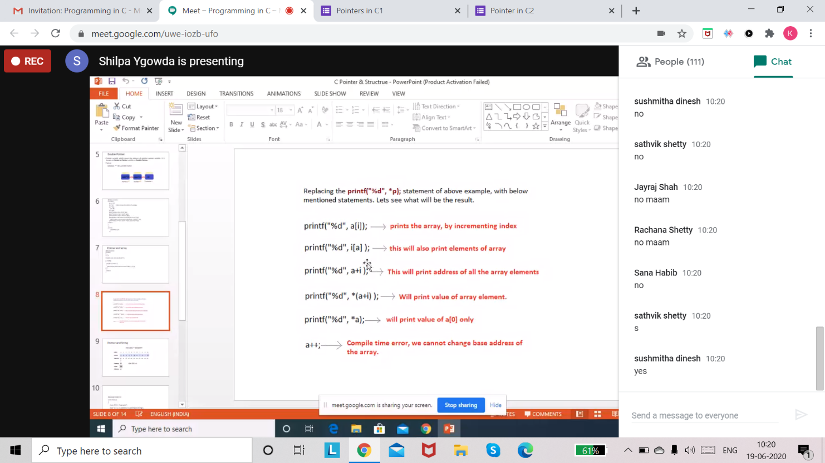

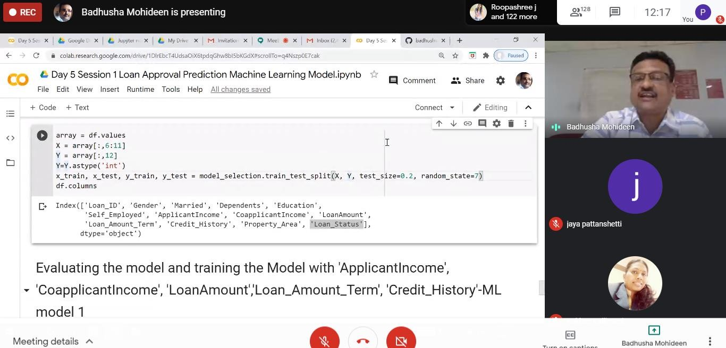

**Coding Challenges Details:**

**Program 1**

This is output of java program to create a doubly linked list of n nodes and display it in reverse order.

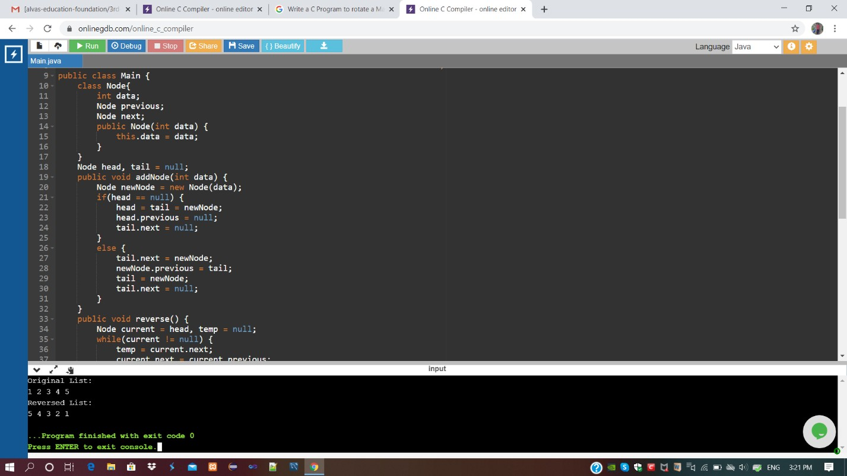

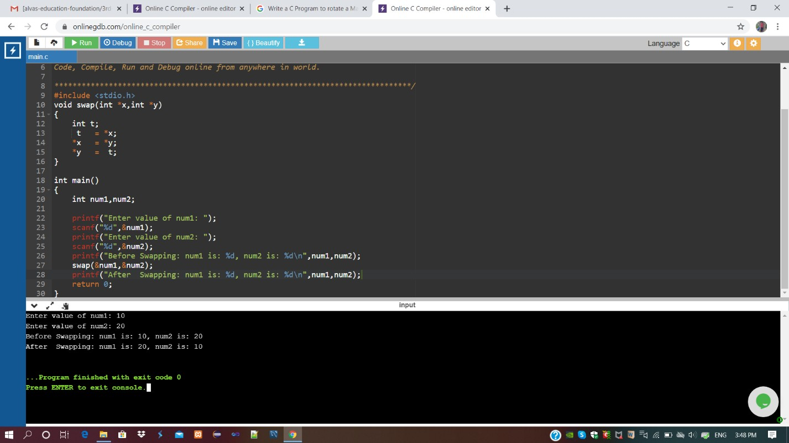

# Program3

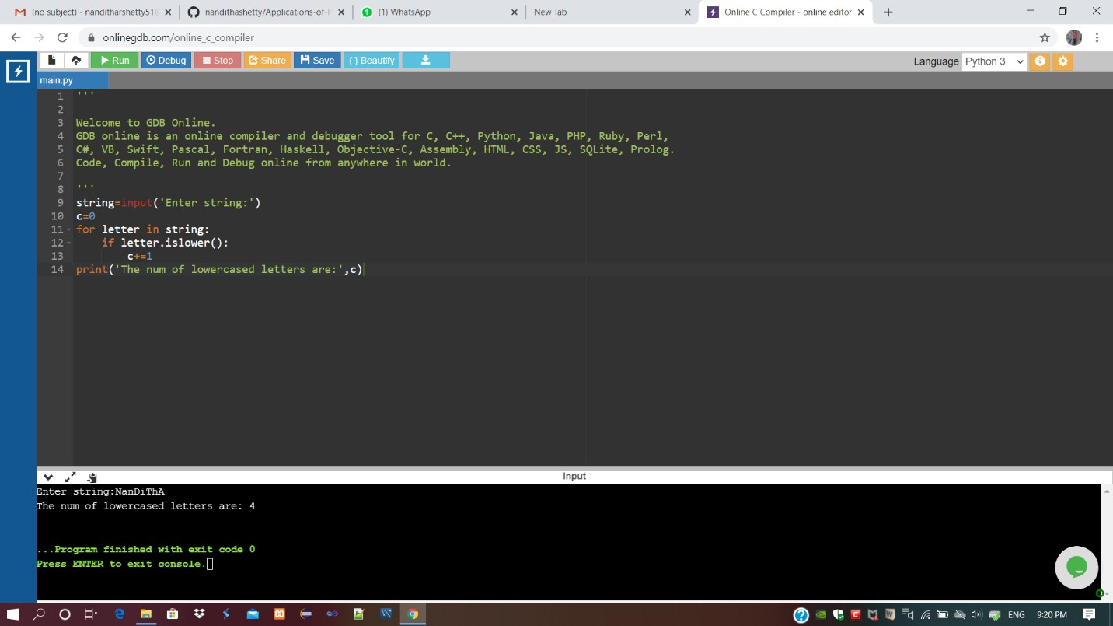

Refer GitHub for detailed Information:<https://github.com/kavya-shetty765/DAILY-STATUS/tree/master/19-06-> [2020/ONLINE%20CODING](https://github.com/nandithashetty/DAILY-STATUS/tree/master/19-06-2020/ONLINE%20CODING)

# Workshop on “Applications of Python Programming in DA and ML”

Today’s exercise uploaded in :

<https://github.com/kavya-shetty765/Applications-of-Python-Programming-in-DA-> [and-ML](https://github.com/nandithashetty/Applications-of-Python-Programming-in-DA-and-ML)

This Report is also available in:

<https://github.com/kavya-shetty765/DAILY-STATUS/tree/master/19-06-2020>